KasiCrafts
ANDROID MARKETPLACE | PROJECT DOCUMENTATION & SUBMISSION REPORT
Student: Tebogo Mabusela • Institution: IIE Rosebank College
Repository: https://github.com/Tebogo791/KasiCrafts
Working branch: fix/marketplace-search-and-upload • Date: 5 November 2026
Evidence note: Replace each marked box with an authentic screenshot from your project. Do not submit placeholders as evidence.

1. Purpose and problem statement
KasiCrafts is an Android marketplace prototype intended to help South African craft makers display handmade products and help buyers discover locally produced items. It focuses on product visibility, browsing, location-based discovery, and a simple shopping basket. The app is a demonstration project: sample products are labeled, and online checkout or escrow payments are not yet implemented.

2. Design considerations
- User experience: a dark interface with orange accents, prominent product imagery, a search bar, category chips, and bottom navigation.
- Accessibility and localization: English, isiZulu, and Afrikaans resource files; language switching and translation completeness require final testing.
- Technology: Kotlin Android fragments, Firebase Authentication, Cloud Firestore and legacy Realtime Database product retrieval, RecyclerView, Glide for images, and Gradle builds.
- Reliability: clearly labeled sample products provide an immediate demonstration catalog when live data is unavailable; live listings should replace them when retrieved.
- Security: Firebase-managed authentication; seller-upload permissions and production privacy practices must be verified before public release.
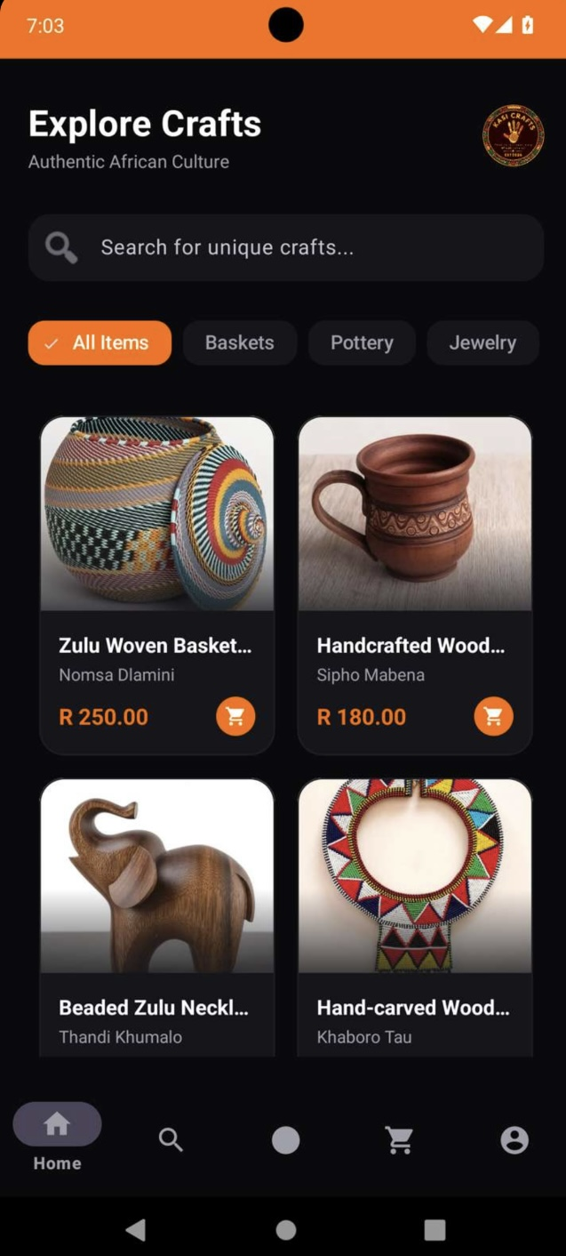
English Home — products and category filters
Captured marketplace demonstration.
Figure: Home marketplace

3. Implemented app modules

3.1 Login and registration
Email/password login and registration are implemented in source code, with email verification logic. A clearly labeled demo browsing option was added for assessment. Google Sign-In requires matching Firebase OAuth configuration and should not be advertised until verified.
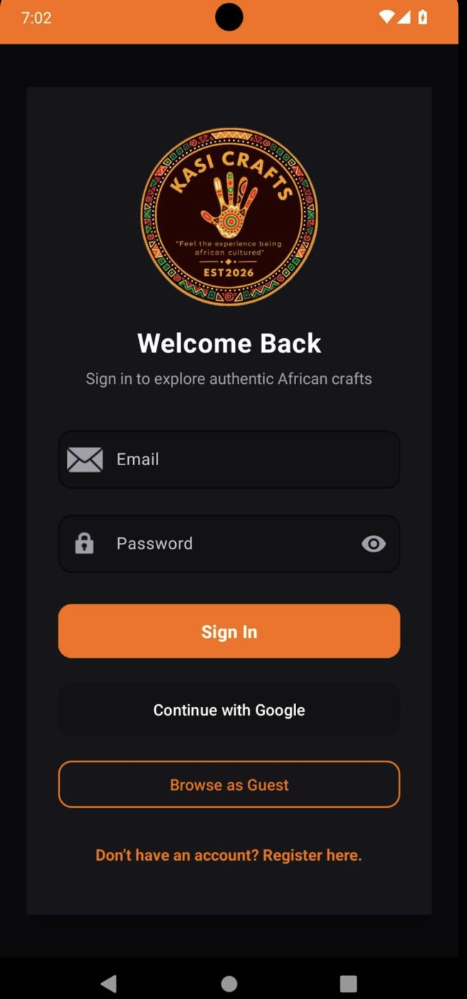
Login and guest access
Authentication screen captured in Appetize.
Figure: Login / demo browsing

3.2 Home and Discover
Home presents a two-column catalog and category chips. Discover presents a vertical listing with product and seller-area search. The repository attempts to load Firebase products and falls back to a labeled set of twelve sample products for demonstration. Image loading uses Glide and needs visual confirmation on Appetize.
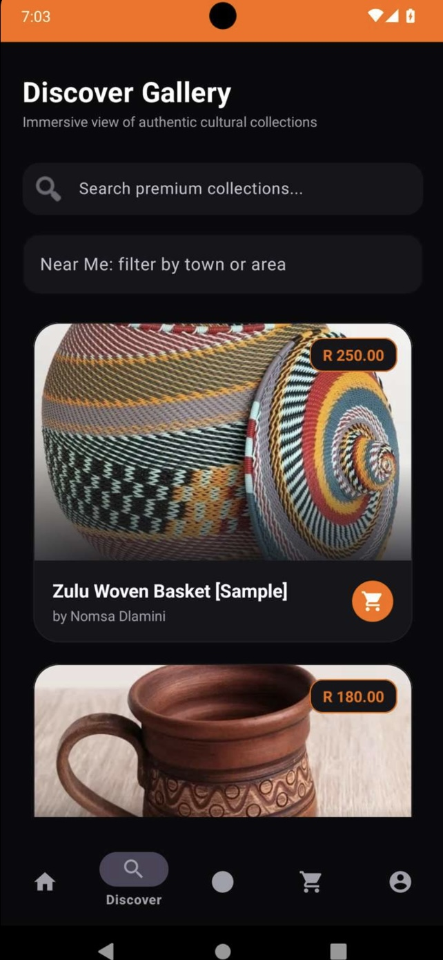
Discover gallery and seller-area filter
Visible search and location-filter controls.
Figure: Discover and search

3.3 Sell, Cart and Settings
The Sell screen provides a product submission interface backed by Firebase code. The basket can add items and calculate totals, but checkout/payment is not available. Settings provides language choices; verify all three languages on-device before claiming full localization.
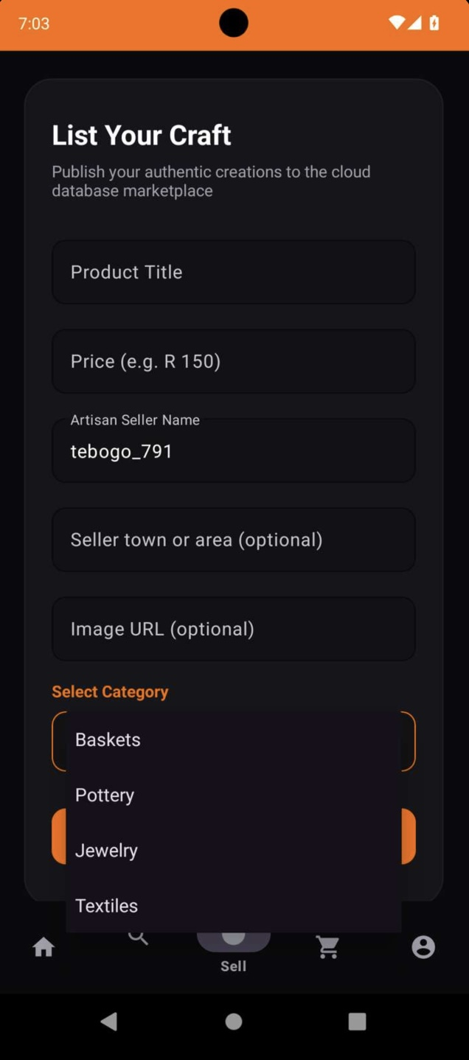
Seller listing form
Product entry fields and category choices.
Figure: Sell product screen
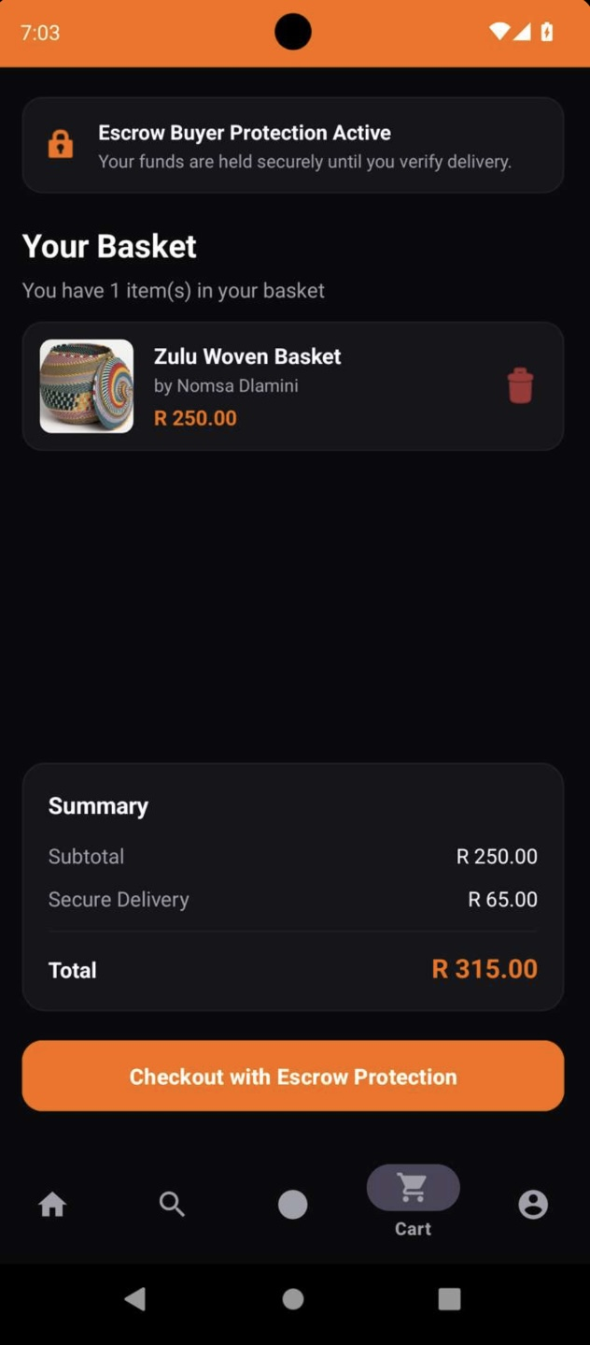
Cart total
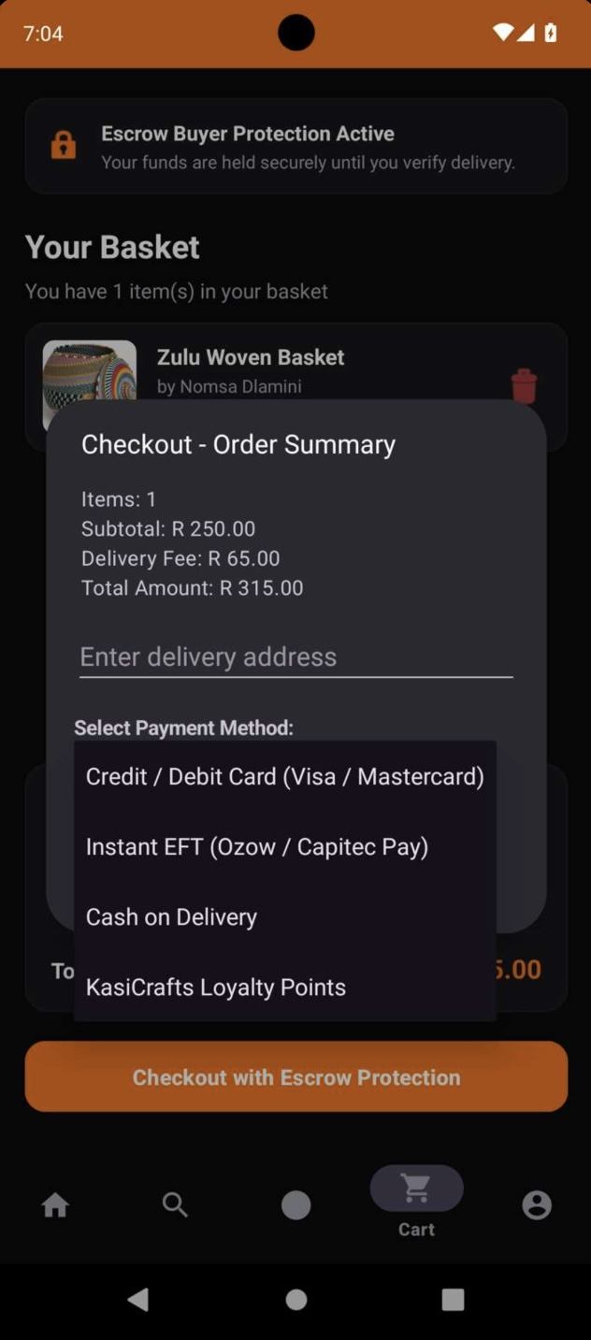
Checkout selection dialog
Checkout options shown are UI demonstrations; escrow/payment processing is not verified.
Figure: Shopping cart
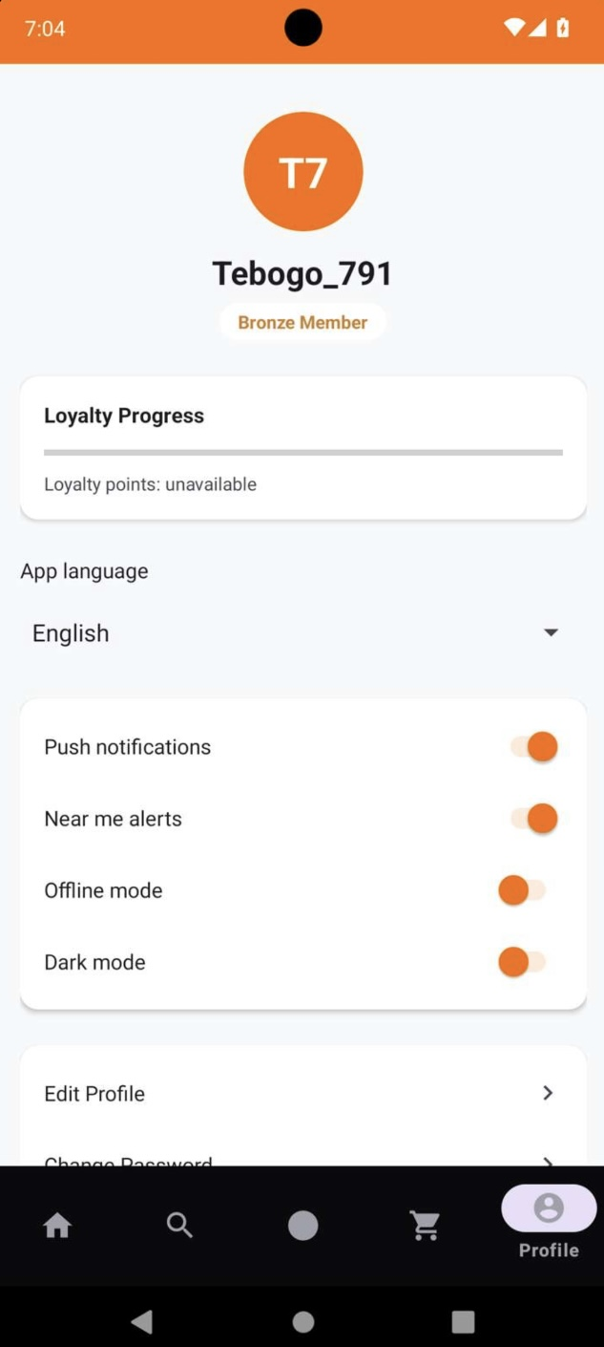
Profile and language selection
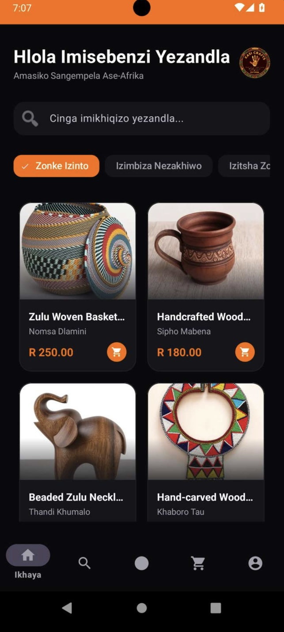
Home translated into isiZulu
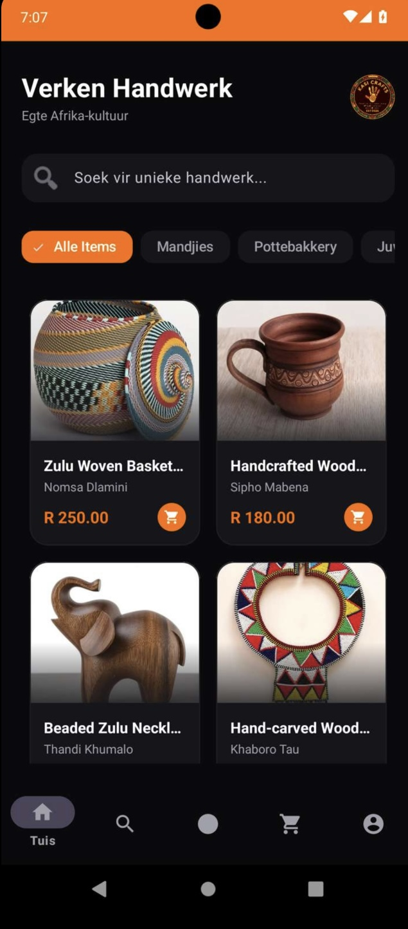
Home translated into Afrikaans
English, isiZulu and Afrikaans Home views documented.
Additional Profile and Settings interface evidence:
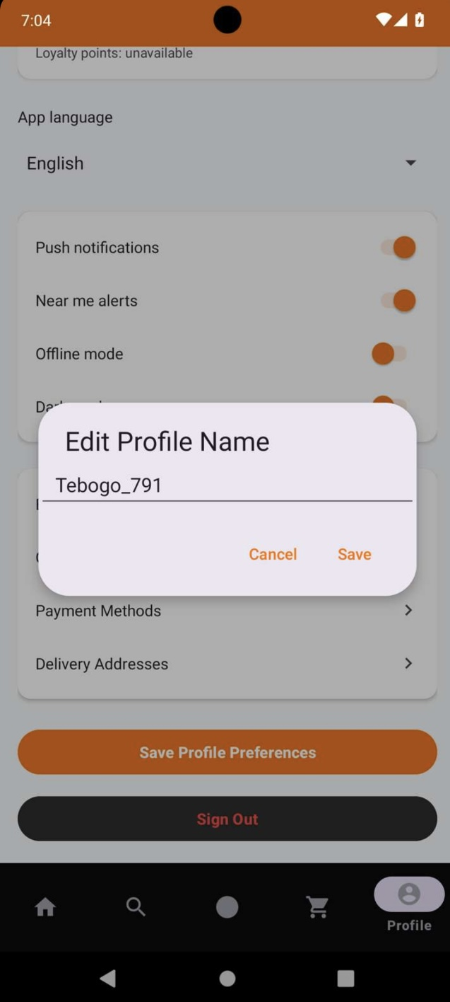
Profile name editing dialog
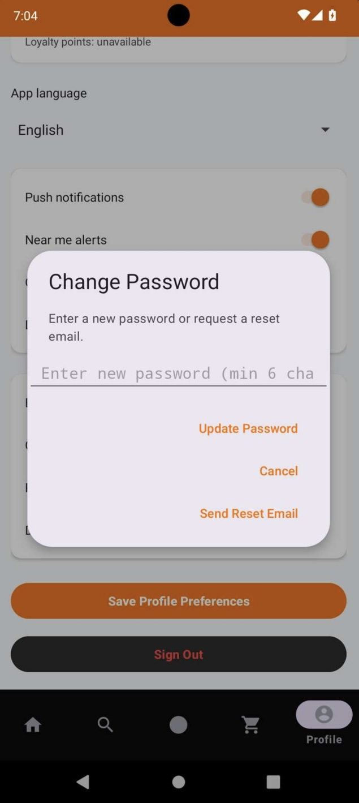
Password update and reset options
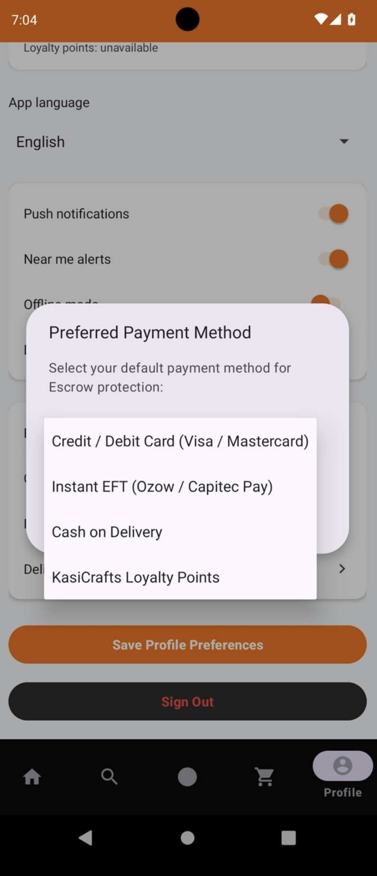
Preferred payment method selection
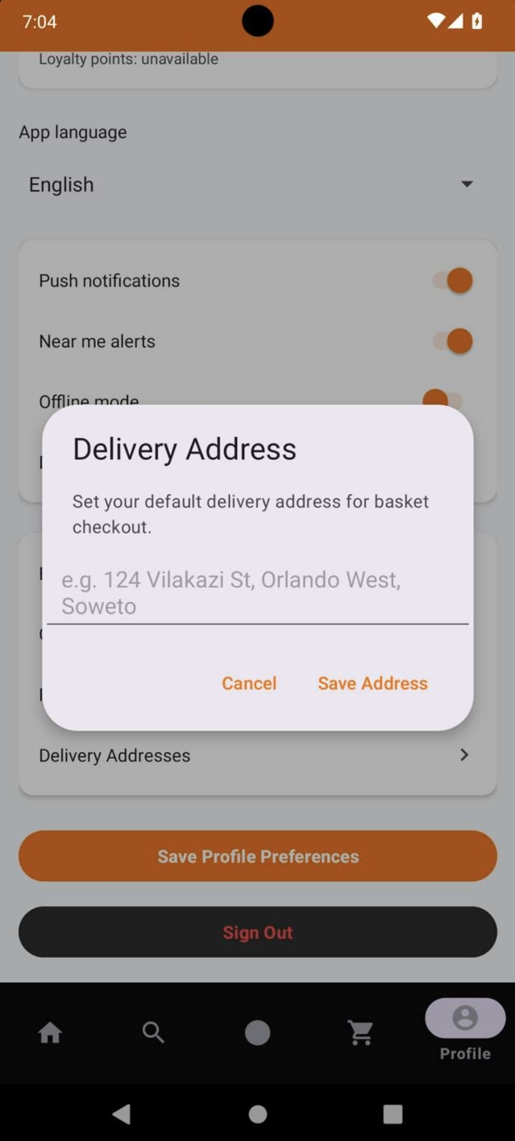
Delivery address form
Figure: Language settings

4. GitHub and GitHub Actions
GitHub hosts the Kotlin source, resources, Gradle configuration, documentation, and version history. Development changes were committed on the fix/marketplace-search-and-upload branch. A GitHub Actions workflow exists at .github/workflows/android-verify.yml to build and run tests automatically. Previous workflow runs encountered Android SDK installation failures; therefore CI success is not yet verified. The latest known local debug APK build completed successfully.
[ INSERT SCREENSHOT: GitHub repository and source ]
Capture repository root showing app/, README.md, Gradle files, and current branch.
Figure: GitHub repository and source
[ INSERT SCREENSHOT: GitHub Actions workflow and run result ]
Capture the Actions page showing the actual run status. If red, explain the failure; do not label it successful.
Figure: GitHub Actions workflow and run result

5. Testing, logging and code quality
The project includes application logging for Firebase messaging and login errors, Kotlin code comments, and a JUnit testing setup. For submission, capture a real successful Gradle build and a test result, then review code comments for accuracy and cite any external material used. Avoid claiming comprehensive tests without evidence.
[ INSERT SCREENSHOT: Successful Gradle build ]
Capture PowerShell or Android Studio showing BUILD SUCCESSFUL for the final source revision.
Figure: Successful Gradle build
[ INSERT SCREENSHOT: Logging / test evidence ]
Capture Android Studio Logcat or relevant source Log statements, plus JUnit results where available. Never expose tokens or passwords.
Figure: Logging / test evidence

6. Publication readiness
The assignment requests evidence that the application is ready to be published, not necessarily a live public store listing. Required evidence includes a signed APK, screenshots and, if applicable, a Play Console upload screenshot. A debug APK is not a signed release deliverable. The production signing key must remain private and must not be uploaded to GitHub.
- Build and test the latest code; resolve crashes and broken flows.
- Generate a signed release APK through Android Studio: Build > Generate Signed Bundle / APK > APK; create and securely back up the keystore.
- Optionally generate a signed AAB for future Google Play submission; ensure release signing is configured.
- Verify app icon, store graphics, screenshots, privacy policy, target SDK and store disclosures against current Play requirements.
- Include an actual Play Console screenshot only if you have uploaded the app there. No paid Play Console account is necessary merely to demonstrate preparation.
[ INSERT SCREENSHOT: Signed APK evidence ]
Capture the Generate Signed Bundle / APK success screen or release APK details, hiding keystore passwords and private file paths.
Figure: Signed APK evidence
[ INSERT SCREENSHOT: Play Store preparation assets ]
Capture the app icon, feature graphic and store screenshots together; include Play Console upload only if actually performed.
Figure: Play Store preparation assets

7. Release notes — changes since prototype
Version 1.0 — assessment demonstration build (release verification pending)
- Expanded product retrieval to Firestore and legacy Realtime Database with alternate field-name support.
- Added twelve clearly labeled sample crafts for demonstration when live products are unavailable.
- Improved Home and Discover search, category browsing and seller-area filtering.
- Added language resources and a language selection interface for English, isiZulu and Afrikaans.
- Added a demo marketplace entry option without requiring Firebase account registration.
- Added a GitHub Actions build/test workflow (currently requires CI troubleshooting).
- Improved shopping-basket presentation while clearly indicating that checkout is unavailable.

8. Video presentation
Existing README video link: https://youtu.be/OWqQ7na4WzA?si=lSZgIle-5jIWdE5X
Before submitting, confirm this video reflects the latest build. Record a voice-over explaining the purpose, architecture, product browsing, searching, selling, basket, language settings, Firebase and GitHub Actions. Add the final link to README.md.
[ INSERT SCREENSHOT: Video evidence ]
Insert a screenshot of the video page or title frame with the link visible.
Figure: Video evidence

9. AI tool use declaration (under 500 words)
ChatGPT was used as a development assistant to help review Kotlin source code, suggest Firebase product-loading improvements, draft demonstration catalog data, troubleshoot Gradle and GitHub Actions problems, and structure the project documentation. Suggestions were incorporated into the GitHub project and should be verified through builds and manual testing. AI-generated content does not replace the student’s responsibility to understand, test, and explain the submitted application. Tool: OpenAI ChatGPT (2026), accessed 5 November 2026.

10. Final submission checklist
☐ Complete Kotlin source code on GitHub (no ZIP)
☐ README includes purpose, design, GitHub and Actions, images and release notes
☐ Code comments, references and logging evidence
☐ Voice-over video and link in README
☐ Screenshots of real app screens
☐ Signed RELEASE APK evidence (not debug only)
☐ Play Console upload screenshot only if applicable
☐ AI-use write-up and citations if applicable
☐ Verify app functionality and final build before submission

11. Screenshot placement guide
Section | Picture to insert | Where to obtain it
2 | Home screen | Appetize
3.1 | Login / registration | Appetize
3.2 | Discover + search results | Appetize
3.3 | Sell, Cart, Settings | Appetize
4 | Repository files + Actions status | GitHub website
5 | Build and logging/test results | PowerShell / Android Studio
6 | Signed APK + graphics | Android Studio / assets
8 | Video screenshot | YouTube

12. How to obtain publication preparation proof
Your rubric requests a signed APK, screenshots and a Play Console upload screenshot and/or Play Store listing if applicable. Since you do not have a Play Console account, do not claim to have uploaded or published the app. Submit truthful preparation evidence and explain that a Console screenshot is not applicable.

Step 1 — Generate a signed release APK in Android Studio
Open C:\KasiCrafts-Final in Android Studio. Select Build > Generate Signed Bundle / APK > APK > Next. Choose Create new to create a private keystore, select an alias and strong passwords, and save the keystore outside the GitHub repository. Choose release and finish. Save the generated signed release APK and take a screenshot of the successful build/output path. Do not include keystore passwords or private signing files in the submission.

Step 2 — Verify the signed APK
Use Android Studio Build > Analyze APK or the Android SDK apksigner tool to inspect the release APK. If apksigner is available, run: apksigner verify --verbose --print-certs "PATH_TO_SIGNED_APK". Capture a screenshot showing successful verification (hide private paths if necessary). A debug APK does not count as signed release proof.

Step 3 — Capture actual application screenshots
Upload the signed APK to Appetize.io if supported, or use a compatible test build, and capture Home (products), Discover (search), Sell, Cart and Settings (languages). The screenshots must show the actual app running. Label sample products as demonstrations; do not represent them as real seller inventory.

Step 4 — Prepare a Play Store bundle (AAB)
Repeat Build > Generate Signed Bundle / APK, this time selecting Android App Bundle. Sign it with the private upload key and capture the build-success screen and the generated .aab file. New Play Store apps are normally submitted as AAB files; the signed APK is still useful because your rubric explicitly asks for it.

Step 5 — Play Console upload screenshot (only if applicable)
A genuine Play Console upload screenshot requires access to a registered Google Play Console developer account. With an account, create the app, open Test and release > Testing > Internal testing, create a release, upload the signed AAB, and capture the page showing the uploaded bundle and app/version. Do not fabricate this screenshot. Account registration has a one-time fee, so if you do not register, mark this item “Not applicable — no Play Console account; signed release and store-preparation evidence supplied.”

Recommended evidence captions
Figure P1: Android Studio — Generate Signed Bundle/APK wizard.
Figure P2: Signed release APK output and verification.
Figure P3: Signed AAB output.
Figure P4: KasiCrafts Home screen running in Appetize.
Figure P5: KasiCrafts Discover and search.
Figure P6: Play Console upload (only if genuinely uploaded).

13. References (Harvard style)
Android Developers (n.d.) Build your app for release to users. Available at: https://developer.android.com/build/build-for-release (Accessed: 5 November 2026).
Android Developers (n.d.) Sign your app. Available at: https://developer.android.com/studio/publish/app-signing (Accessed: 5 November 2026).
Firebase (n.d.) Firebase documentation. Available at: https://firebase.google.com/docs (Accessed: 5 November 2026).
GitHub Docs (n.d.) GitHub Actions documentation. Available at: https://docs.github.com/en/actions (Accessed: 5 November 2026).
Google Play Console Help (n.d.) Prepare and roll out a release. Available at: https://support.google.com/googleplay/android-developer/answer/9859348 (Accessed: 5 November 2026).
Google Play Console Help (n.d.) Set up an open, closed, or internal test. Available at: https://support.google.com/googleplay/android-developer/answer/9845334 (Accessed: 5 November 2026).
OpenAI (2026) ChatGPT [Large language model]. Used for Kotlin development assistance, troubleshooting and report drafting, 5 November. Available at: https://chatgpt.com/ (Accessed: 5 November 2026).

The following images are screenshots supplied from the running KasiCrafts Android application. They demonstrate visible interfaces, not necessarily successful backend transactions. Sample catalog listings are demonstration data. Screenshots are original application evidence (Mabusela, 2026).
Figure A1. Login screen with guest browsing option. | Figure A2. English Home marketplace with product cards.
Evidence note: Screen content is shown as captured; visible controls and sample products do not establish that payments, escrow or cloud uploads are functional.

Figure A3. Discover Gallery with search and area filter. | Figure A4. Seller product listing form and categories.
Evidence note: Screen content is shown as captured; visible controls and sample products do not establish that payments, escrow or cloud uploads are functional.

Figure A5. Basket summary and delivery calculation. | Figure A6. Checkout dialog showing payment choices (interface only).
Evidence note: Screen content is shown as captured; visible controls and sample products do not establish that payments, escrow or cloud uploads are functional.

Figure A7. Profile, language and preferences screen. | Figure A8. Edit profile name dialog.
Evidence note: Screen content is shown as captured; visible controls and sample products do not establish that payments, escrow or cloud uploads are functional.

Figure A9. Password change/reset dialog. | Figure A10. Preferred payment method dialog (not payment processing).
Evidence note: Screen content is shown as captured; visible controls and sample products do not establish that payments, escrow or cloud uploads are functional.

Figure A11. Delivery address entry dialog. | Figure A12. isiZulu Home interface.
Evidence note: Screen content is shown as captured; visible controls and sample products do not establish that payments, escrow or cloud uploads are functional.

Figure A13. Afrikaans Home interface.
Evidence note: Screen content is shown as captured; visible controls and sample products do not establish that payments, escrow or cloud uploads are functional.

